Cloud Overview

Cloud Type

Software service model

Services

Region

IAM

VPC

Cloud Overview

Cloud computing is the on-demand availability of computer system resources, especially data storage and computing power, without direct active management by the user. The term is generally used to describe data centers available to many users over the Internet.

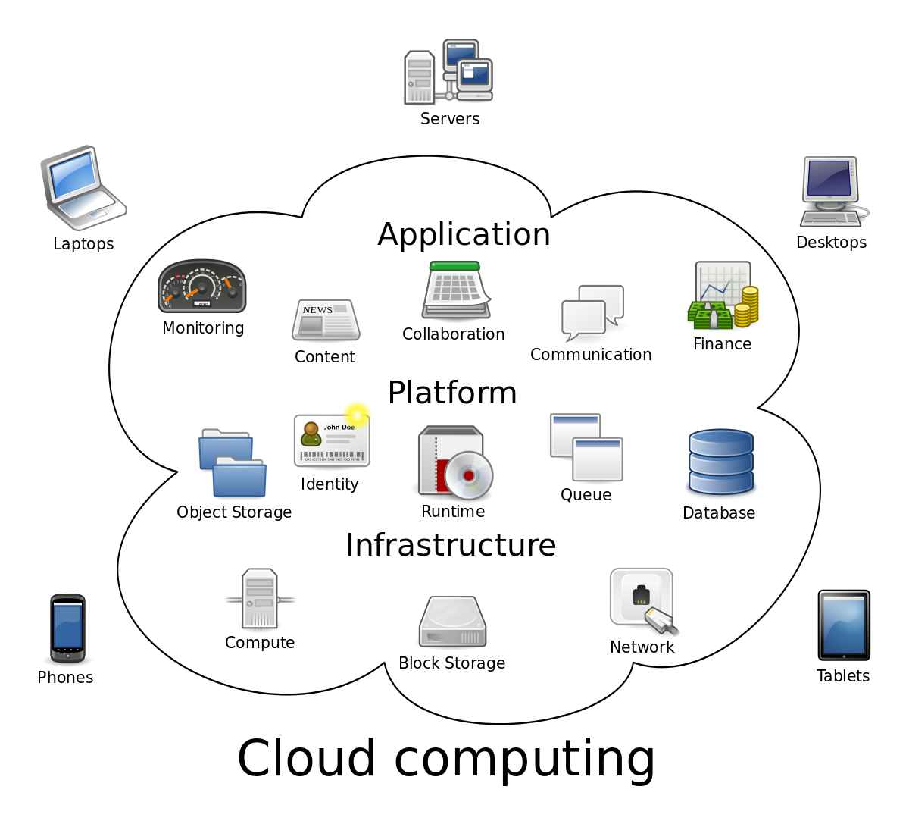

Advantages

Reduce Cost & Operational Burden

Seamless Integration

Centralized data & management

Cloud Type

* Public **cloud**:
* Private **cloud**:
* Hybrid **cloud**:

Software service model

## ****IaaS****

IaaS or Infrastructure as a Service is basically a virtual provision of computing resources over the cloud. An IaaS cloud provider can give you the entire range of computing infrastructures such as storage, servers, networking hardware alongside maintenance and support.

Businesses can opt for computing resources of their requirement without the need to install hardware on their premises.  Amazon Web Services, Microsoft Azure, and Google Compute Engine are some of the leading IaaS cloud service providers.

## ****PaaS****

Platform as a Service or PaaS is essentially a cloud base where you can develop, test and organize the different applications for your business. Implementing PaaS simplifies the process of enterprise software development. The virtual runtime environment provided by PaaS gives a favorable space for developing and testing applications.

The entire resources offered in the form of servers, storage and networking are manageable either by the company or a platform provider. Google App Engine and AWS Elastic Beanstalk are two typical examples of PaaS. PaaS is also subscription based that gives you flexible pricing options depending on your business requirements.

**SaaS**

SaaS or Software as a Service is a model that gives quick access to cloud-based web applications. The vendor controls the entire computing stack, which you can access using a web browser. These applications run on the cloud and you can use them by a paid licensed subscription or for free with limited access.

Services

### Service #1 - Amazon S3(Simple Storage Service)

Amazon S3 is listed top in the AWS services list - because, storing and retrieving the data plays a prominent role in cloud computing. So, AWS offers a wonderful service called Amazon Simple Storage Service or Amazon S3 to store and retrieve data from the cloud. S3 allows the user to store, upload, retrieve large files up to 5 TB from the cloud. It is a scalable, low-cost and high-speed web-based service designed for archival and online backup of application programs and data. Using S3, the user can access the same system that Amazon uses to run its website. Users have control over the public or private accessibility of the data.

### Service #2 - Amazon EC2 [Elastic Compute Cloud]

Amazon EC2 provides scalable computing capacity in the AWS cloud. Using Amazon EC2, you can develop and deploy applications quickly and effectively for a low cost. And also you can use Amazon EC2 to launch virtual servers according to your requirements.

### Service #3 - AWS Lambda

Amazon Lambda is a service that allows the user to run code without any server. Amazon Lambda executes the code only when the user needed and scales automatically. Users pay only for the compute time, no need to charge when your code is not running. This service supports the code written in Node.js, Java, Python, and languages supported by Amazon Linux.

### Service #4 - Amazon Glacier

Amazon Glacier is one of the most important services provided by AWS. The Glacier is an online web storage service that provides you with low cost and effective storage with security features for archival and data backup. With Glacier, you can store the information effectively for months, years, or even decades.

### Service #5 - Amazon SNS (Simple Notification Service)

Amazon SNS is a web service provided by the AWS. SNS stands for Simple Notification Service, and it manages and delivers the messages or notifications to the users and clients from any cloud platform. In SNS, there are two types of clients, subscribers, and publishers. Publishers produce and send a message to the subscriber instance through the communication channels. Subscribers receive notification from the publisher over one of the supported protocols such as Amazon SQS, HTTP, and Lambda, etc. Amazon SNS automatically triggers the service and sends an email with a message that “ your EC2 instance is growing” when you are using Auto Scaling. Amazon SNS automatically triggers the service and sends an email with a message that **“ your EC2 instance is growing”** when you are using Auto Scaling.

### Service #6 - Amazon CloudFront

To Know how fast your website is working, you can use the CloudFront service. It speeds up the sharing of your dynamic and static web content such as .css, .html and image files to your users. It securely delivers your images, videos, data and applications to users and clients with high transfer speed and low latency, all within a developer-friendly environment.

### Service #7 - Amazon EBS [Elastic Block Store]

EBS is an Amazon service, which is used to store persistent data, and it is block-level storage to use EC2 instances. You can use EBS service, to move the data from one instance to another instance without losing the stored data at EBS. You can mount multiple volumes on the same instance, but each volume can be attached to a single instance at a time.

### Service #8 - Amazon Kinesis

Are you worried about how to deal with the large volume of data? AWS is offering Amazon Kinesis service to handle big data in real-time. It allows developers to take any large volume of data from any source that can run on EC2 instance. It stores, capture and processes the data from large distributed streams like social media feeds and log events. After completion of processing the data, it distributes the data to the consumers simultaneously.

### Service #9 - Amazon VPC

Is my data secure in the AWS Cloud? Yes, your information is secure in the AWS cloud with the Amazon VPC service. Using the Virtual Private Network, the data is secured because only authorized people can view the data. So, the information is not exposed to outside people or networks.

### Service #10 - Amazon SQS

Amazon SQS stands for Simple Queue Service, and it manages the message queue service. Using this service, you can move the data or message from one application to another even though it is not in the running or active state. SQS sends messages between multiple services, including S3, DynamoDB, EC2 Instance, and also it uses the Java message queue service to deliver the information. The maximum visibility timeout of a message is 12 hours in the SQS queue.

### Service #11 - Amazon Elastic Beanstalk

Developers can easily deploy the services and web applications developed with .NET, Java, PHP, Python and more without providing any infrastructure. A number of cloud clients, including Amazon Web Services, Microsoft Azure, offer development tools to make the process easy and simple.

### Service #12 – DynamoDB

It is a fully managed NoSQL database service that supports document data structures and key values that are offered by Amazon.com. DynamoBD allows you to create the database tables so that you can retrieve and store any format of data. It controls the data traffic over multiple servers and maintains the performance of the tables.

### Service #13 - Amazon RDS [Relational Database Service]

It is a fully SQL database cloud service that allows users to operate and create relational databases. RDS can manage from any AWS Management Console. Using RDS, you can access files and databases from anywhere in a highly scalable and cost-effective way

### Service #14 - Amazon ElastiCache

It is a memory cache system service on the cloud and supports Redis and Memcached. ElasticCache improves the memory performance by CPU Intensive Queries and Caching I/O queries in memory for quick results. It integrates with all other services, and you can manage from both user API and management console. Using Virtual Private Cloud, you can run the Elasticache cluster in Amazon

### Service #15 - Amazon Redshift

It is a fully managed data warehouse service in the cloud. Redshift gives you to access structured data from the existing SQL, ODBC, and JDBC. When you are executing the large query, it divides the query into small parts and assigns them among the multiple nodes for parallel operations. According to the user requirements, it controls the nodes in the Redshift.

Region

Amazon cloud computing resources are hosted in multiple locations world-wide. These locations are composed of AWS Regions and Availability Zones. Each AWS Region is a separate geographic area. Each AWS Region has multiple, isolated locations known as Availability Zones. Amazon RDS provides you the ability to place resources, such as instances, and data in multiple locations. Resources aren't replicated across AWS Regions unless you do so specifically.


   Single AZ Scenario
  

## Regional Endpoints

Most Amazon Web Services offer a Regional endpoint that you can use to make your requests. The general syntax of a Regional endpoint is as follows.

*protocol*://*service-code*.*region-code*.amazonaws.com

Amazon RDS supports the endpoints listed in the following table.

|  |  |  |  |
| --- | --- | --- | --- |
| **Region Name** | **Region** | **Endpoint** | **Protocol** |
| US East (Ohio) | us-east-2 | rds.us-east-2.amazonaws.com | HTTPS |
| US East (N. Virginia) | us-east-1 | rds.us-east-1.amazonaws.com | HTTPS |
| US West (N. California) | us-west-1 | rds.us-west-1.amazonaws.com | HTTPS |
| US West (Oregon) | us-west-2 | rds.us-west-2.amazonaws.com | HTTPS |
| Asia Pacific (Hong Kong) | ap-east-1 | rds.ap-east-1.amazonaws.com | HTTPS |
| Asia Pacific (Mumbai) | ap-south-1 | rds.ap-south-1.amazonaws.com | HTTPS |
| Asia Pacific (Osaka-Local) | ap-northeast-3 | rds.ap-northeast-3.amazonaws.com | HTTPS |
| Asia Pacific (Seoul) | ap-northeast-2 | rds.ap-northeast-2.amazonaws.com | HTTPS |
| Asia Pacific (Singapore) | ap-southeast-1 | rds.ap-southeast-1.amazonaws.com | HTTPS |
| Asia Pacific (Sydney) | ap-southeast-2 | rds.ap-southeast-2.amazonaws.com | HTTPS |
| Asia Pacific (Tokyo) | ap-northeast-1 | rds.ap-northeast-1.amazonaws.com | HTTPS |
| Canada (Central) | ca-central-1 | rds.ca-central-1.amazonaws.com | HTTPS |
| China (Beijing) | cn-north-1 | rds.cn-north-1.amazonaws.com.cn | HTTPS |
| China (Ningxia) | cn-northwest-1 | rds.cn-northwest-1.amazonaws.com.cn | HTTPS |
| EU (Frankfurt) | eu-central-1 | rds.eu-central-1.amazonaws.com | HTTPS |
| EU (Ireland) | eu-west-1 | rds.eu-west-1.amazonaws.com | HTTPS |
| EU (London) | eu-west-2 | rds.eu-west-2.amazonaws.com | HTTPS |
| EU (Paris) | eu-west-3 | rds.eu-west-3.amazonaws.com | HTTPS |
| EU (Stockholm) | eu-north-1 | rds.eu-north-1.amazonaws.com | HTTPS |
| Middle East (Bahrain) | me-south-1 | rds.me-south-1.amazonaws.com | HTTPS |
| South America (Sao Paulo) | sa-east-1 | rds.sa-east-1.amazonaws.com | HTTPS |
| AWS GovCloud (US-East) | us-gov-east-1 | rds.us-gov-east-1.amazonaws.com | HTTPS |
| AWS GovCloud (US-West) | us-gov-west-1 | rds.us-gov-west-1.amazonaws.com | HTTP |

IAM

# Setup AWS IAM user

It is a good security (and recommended) practice to create a user on AWS other than your root account. And use the new account key pairs in your AWS and Koding accounts and Stacks.

There are two required policies that need to be enabled for the new IAM user to be able to create & build Stacks using EC2s.

* **AmazonEC2FullAccess**
* **IAMReadOnlyAccess**

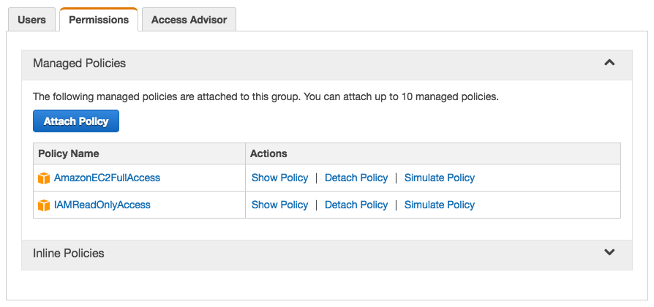

The steps are:

1. Create a new user (make sure to generate the Access Keys and save them)
2. Create a new group and add the user to this group
3. Assign the above two policies (see screenshot) to the created group

Now you can use the new user Access and Secret Keys with your Koding account in the AWS credentials tab to build your stacks.

### Step by step guide

1. Log in to your AWS account, choose **Services**, then choose **IAM** (Identity and Access Management)
2. Create a **new user**
   1. Choose a user name, we created a user called “koding-user”. We also made sure that **Generate an access key for each user is enabled**

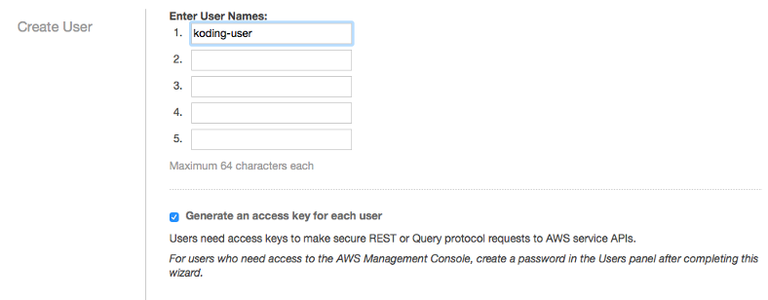

* 1. Click **Show User Security Credentials**



* 1. Save the user’s keys (you can also **download** them) and click **close**

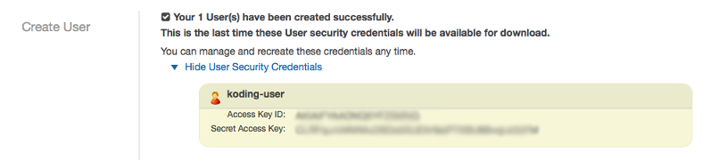

* 1. User **koding-user** created successfully

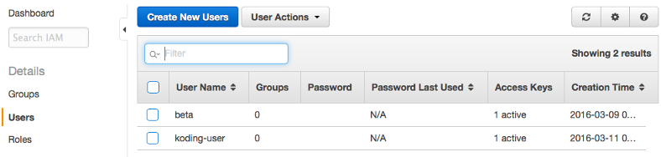

1. Create a **new group** and follow the online wizard
   1. Choose a group name, we choose the name “Developers”

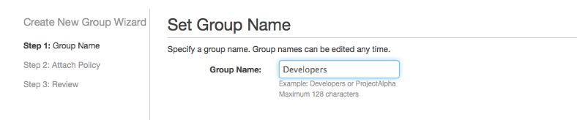

* 1. Choose the access policies
     + **AmazonEC2FullAccess**
     + **IAMReadOnlyAccess**

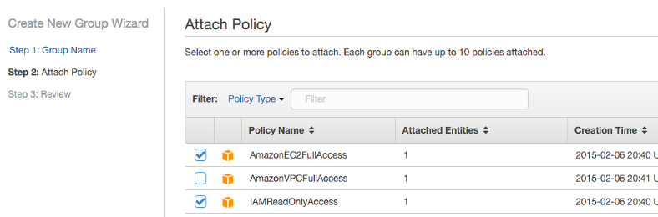

* 1. Review and click **create**

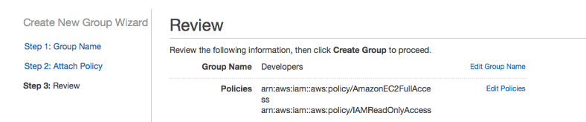

1. Add the user to the group
   1. Go to the **Users** tab, select and check the user you created and click **User Actions** -> **Add Users to Group**

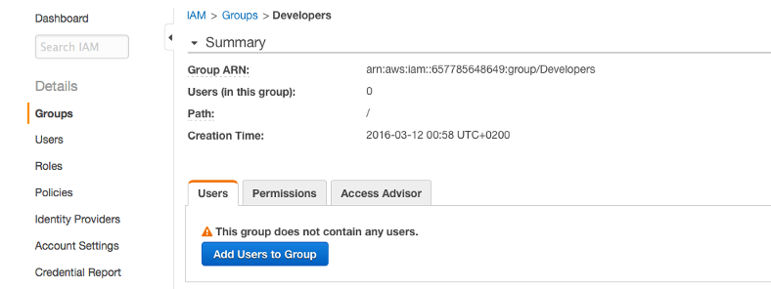

* 1. Select the **koding-user** we just created

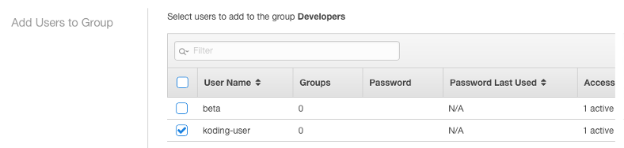

* 1. User was added to group successfully

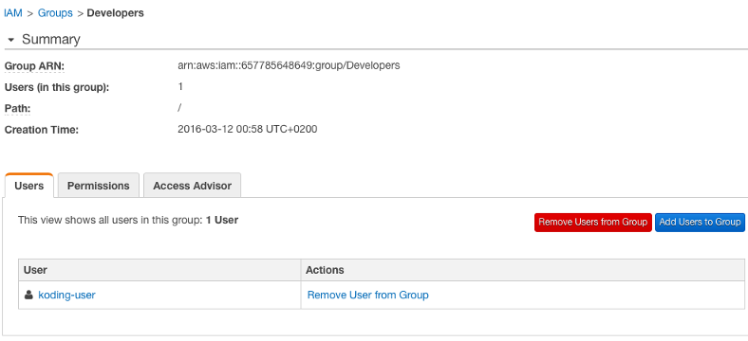

VPC

#### Step1: Create your VPC

Login to your AWS account, From the Services Tab → Select VPC →then Select Your VPC → click on “**Create VPC**”

Specify your VPC Name and CIDR (Classless Inter-Domain Routing), In my case I am using the followings

* VPC Name = Linuxtechi-VPC
* IPV4 CIDR = 192.168.0.0/24

#### Step:2 Create Private Subnets

In this step we will create two private subnets, **Subnet1** (192.168.0.0/25) and **Subnet2** (192.168.0.128/25) across the availability zones. We are calling these subnets as private because  we can’t access  instances from the Internet whenever EC2 instance is getting IP from these subnets. Though after attaching Internet gateway these instances becomes reachable over internet.

From the **VPC Dashboard** click on **Subnets** option and then click on

Create **Subnet**

Specify the followings

* Subnet name as “subnet1”
* VPC ( Linuxtechi-VPC)
* Availability zone as per your region
* IPV4 CIDR “192.168.0.0/25”

click on “Yes, Create”, Similarly  Create **Subnet2** with IPV4 CIDR “192.168.0.128/25”

#### Create a Route table and associate it with your VPC

From VPC Dashboard  there is an option create a Route table. Click on “**Create Route Table**”

Specify the Name of Route Table and Select your VPC, In my case VPC is Linuxtechi-VPC

#### Create Internet Gateway (igw) and attached it to your VPC

From VPC dashboard there is an option to create Internet gateway. Specify the Name of Internet gateway

Once the Internet gateway is created, attached it to your VPC, Select and Right Click Your Internet gateway and then  Select the “**Attach to VPC**” option

Now Add Route to your route Table for Internet, go to**Route Tables**  Option, Select your Route Table, In my case it is “**Lnx-RouteTable**“, click on Route Tab and Click on **Edit** and  the click on “**add another route**”

Mention Destination IP of Internet as “0.0.0.0/0” and in the target option your Internet gateway will be populated automatically as shown below.

#### Change Route table of your VPC Subnet

In above steps we have created two Subnets (Subnet1 and Subnet2), I am going to change the route table of Subnet1.From the **VPC Dashboard**, Click on Subnets,  Select the **Subnet1** and the click on “**Route Table**” Tab and the click on **Edit**.

Change the default Route table to “**Lnx-RouteTable**” and then Click On **Save**

#### Launch APP and DB Server Instance in your VPC

Launch **APP Server** in your VPC using **Subnet1** and**DB Server** using **Subnet2**. Verify whether you are able to access APP Server and DB server from public IP.